

Vehicle Detection Using Image Processing and Deep Learning
Project Report

Prepared By: Kashish Jain
Course: GRAD-695 Applied Project
Date: 09/24/2025

Table of Contents
Introduction 4
Purpose 4
Scope 4
Definitions and Acronyms 4
Overview 5
System Requirements 5
Functional Requirements 5
Non-Functional Requirements 5
Performance Requirements 6
Database Requirements 6
Security and Privacy 6
Software Specifications 6
System Design 7
Architecture 7
Use Case Diagram 8
Class Diagram 10
Sequence Diagram 11
Project Structure and Implementation 12
User Interface Design 21
Detect Image Screen 21
Detect Video Screen 21
Train Model Screen 21
Compare Model Screen 22
Download Processed Result Screen 22
Testing and Evaluation 23
Ethical and Societal Impact 29
Results and Discussion 29
Conclusion and Future Work 29
Appendices 29

Introduction

Purpose
The purpose of this project is to automatically detect vehicles from images and videos using classical image processing and deep learning methods. It processes uploaded media files (images/videos), identifies vehicles frame by frame, and outputs annotated results with bounding boxes.
Key motivations:
- Provide an accessible demo system for vehicle detection research and prototyping.
- Enable comparison between different detection algorithms (Haar Cascade vs CNN baseline, with optional YOLO/SVM).
- Demonstrate frame-by-frame video analysis using OpenCV pipelines.
- Integrate a Flask REST API backend with an Angular frontend for a complete, user-friendly detection application.
- Allow users to download processed outputs for validation and further study.
This project is not a production-ready traffic surveillance tool, it is an educational prototype that combines ML, image processing, and full-stack integration

Scope
- Input: Images/videos or live camera feed.
- Output: Annotated frames with bounding boxes and recognized plate text.
- Modules: Detection, OCR, REST API, frontend.
- Out of scope: Real-world law enforcement integration, large-scale multi-camera traffic analytics.

Definitions and Acronyms
Definitions / Acronyms | Description
API | Application Programming Interface
CNN | Convolutional Neural Network
COCO | Common Object in Context Dataset
FPS | Frames per second
OCR | Optical Character Recognition
ROI | Region of Interest
UI | User Interface

Overview
The project demonstrates a prototype detection pipeline integrating OpenCV, PyTorch/TensorFlow, and Tesseract OCR with a web-based frontend. It emphasizes modularity, educational prototyping, and comparison of detection algorithms

System Requirements

Functional Requirements
- FR1: The system shall allow users to upload images (jpg, .png) for vehicle detection.
- FR2: The system shall allow users to upload videos (mp4, .avi) for vehicle detection.
- FR3: The system shall process videos frame by frame and draw bounding boxes around detected vehicles.
- FR4: The system shall provide two detection models (Haar Cascade, CNN) selectable by the user.
- FR5: The system shall allow users to download processed images/videos from the processed/ folder via REST API.
- FR6: The system shall expose REST endpoints with Swagger UI for API testing (http://localhost:5000/).
- FR7: The system shall provide a web-based frontend (Angular) at http://localhost:4200/ for uploading media and retrieving results.
- FR8: The system shall log job metadata (job id, filename, model, status, timestamps) in an in-memory SQLite database.
- FR9: The system shall validate inputs and return clear error messages for unsupported formats.
- FR10: The system shall save all annotated outputs to the backend/processed/ folder.

Non-Functional Requirements
NFR1 (Performance):
- Haar model should process a 1-minute 720p video in ≤2 minutes on CPU.
- CNN model should complete within an acceptable time (with resized frames).
NFR2 (Usability):
- The frontend UI must be simple: Upload → Run → Download.
NFR3 (Portability):
- The system will run on Windows 10/11 and Ubuntu 20.04+.
NFR4 (Reliability):
- Failed jobs must not create incomplete output files.
NFR5 (Scalability):
- Designed for single-user demo; future extension can support multi-user sessions.
NFR6 (Security):
- Demo mode: no login required.
- Future extension: role-based access for admin and users.
NFR7 (Maintainability):
- Code organized into modules: routes, services, models, data.
NFR8 (Observability):
- Log job lifecycle (start, complete, fail), processing time, number of frames.

Performance Requirements
- Haar model: process 1-min 720p video <= 2 minutes CPU
- CNN model: acceptable with resized frames
- OCR accuracy >= 70% under normal conditions

Database Requirements
- SQLite/Postgres schema for jobs, sessions, frames, detections
- Store metadata: job_id, filename, model, timestamps, results

Security and Privacy
- Admin-only endpoints (future extension)
- Option to blur plate numbers for privacy compliance

Software Specifications
- Backend: Python 3.9+, Flask, Flask-RESTX, SQLAlchemy
- Frontend: Angular, Bootstrap, Swagger docs
- Detection Models: Haar Cascade, CNN, YOLO (extension)
- OCR: Tesseract
- Dataset: COCO 2017

System Design

Architecture
Frontend (Angular)
- Provides the web-based interface for uploading images/videos.
- Allows users to choose detection models (Haar/CNN).
- Displays processing confirmation and links to download results.
- Runs at http://localhost:4200/.
Backend (Flask + Flask-RESTX)
- Provides REST endpoints for detection and downloading processed files.
- Handles file uploads, validates input formats, and manages job lifecycle.
- Runs at http://localhost:5000/.
- Auto-generates API documentation via Swagger.
Detection Service (OpenCV + ML Models)
- Haar Cascade Classifier for quick, classical detection.
- CNN model for improved robustness.
- Processes media files frame by frame for videos.
- Outputs annotated images/videos with bounding boxes.
Storage
- In-memory SQLite DB (via SQLAlchemy) stores temporary job records.
- File outputs are saved to backend/processed/ for later retrieval.
Data
- COCO 2017 dataset used for testing and evaluation.

Use Case Diagram
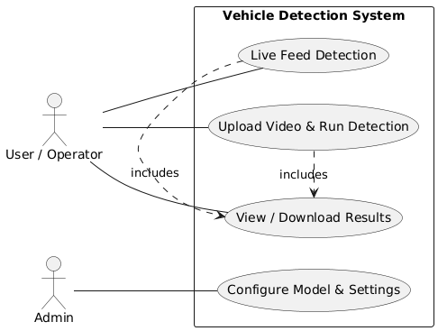

UC1: Upload video & detect
Actors: User (Operator)
Description: Upload a video file and run detection pipeline; view annotated frames & download results.
Preconditions: The user is on the Upload page; the file is less than or equal to the allowed size and supported format.
Main flow:
- User selects file and clicks Upload.
- UI sends file via POST /api/run with params {model, fps, thresholds}.
- Server returns { session_id }.
- Server extracts frames from chosen FPS.
- For each frame: VideoProcessor → InferenceEngine (detect vehicles → detect plates → OCR).
- Server saves detection rows and streams annotated frames to UI.
- UI displays live progress and overlays boxes/text.
- After the job is completed, the user downloads the results CSV/JSON.
Alternate flows:
A1: User cancels upload at step 1 → Server deletes partial upload and returns status canceled.
A2: User chooses evaluation mode instead of run → Server runs evaluation and returns metrics.
Exception flows:
E1: Unsupported file format → UI shows error and lists supported formats; job not created.
E2: Model loading failure (e.g., corrupted model weights) → Server returns error and logs.

UC2: Live feed detection
Actors: User
Description: Connect to a live camera (RTSP) and run real-time detection.
Preconditions: Camera reachable and credentials provided (if needed).
Main flow:
- User provides RTSP URL and params; clicks Start.
- Server connects, streams frame, performs detection/OCR, and streams overlay to UI.
- User clicks Stop to end the session.
Exceptions:
Camera unreachable → show connection error and retry option.
Intermittent disconnect → server attempts N retrieves; if it fails, marks the session fail.

UC3: Admin config
Actors: Admin
Description: Admin logs in, changes the detection model, sets thresholds, and retention.
Preconditions: Admin authenticated.
Main flow: The admin posts to /api/config with the new model name and parameters; the server validates and saves the config for subsequent runs.
Exceptions: Unauthorized access → 403 response.

UC4: Download results
Actors: User
Description: Download session results as JSON/CSV and evaluation report (if available).
Main flow: User opens session page and clicks Download; server returns file stream.

Class Diagram

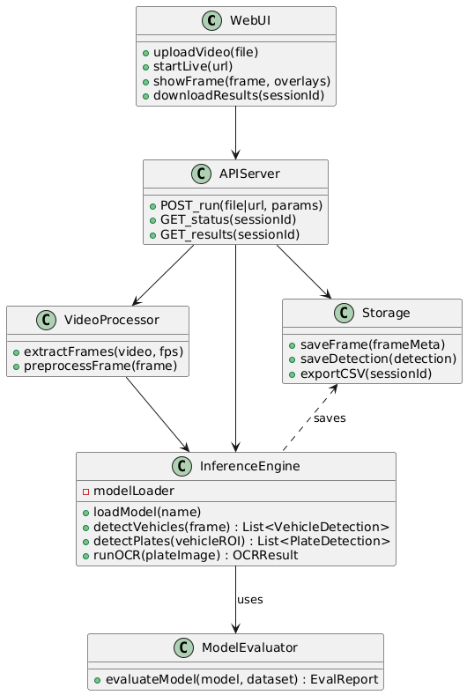

Sequence Diagram

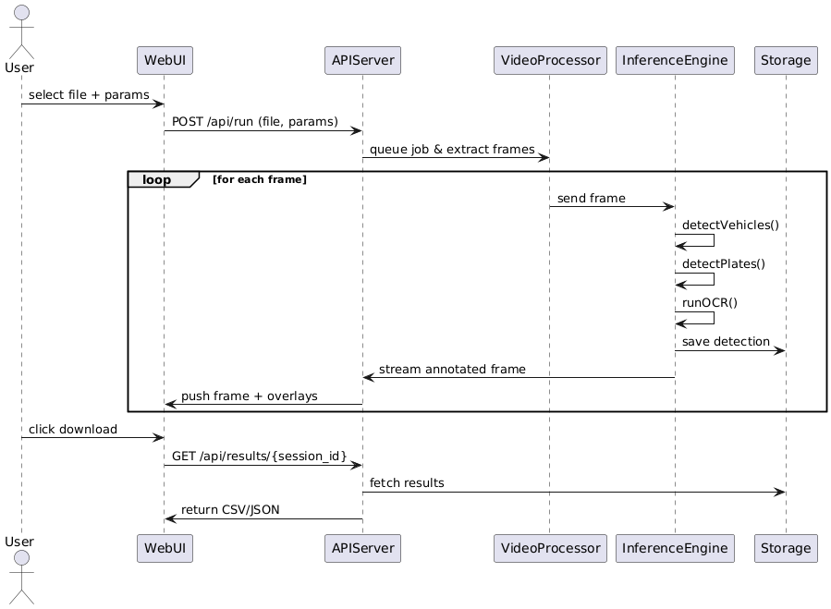

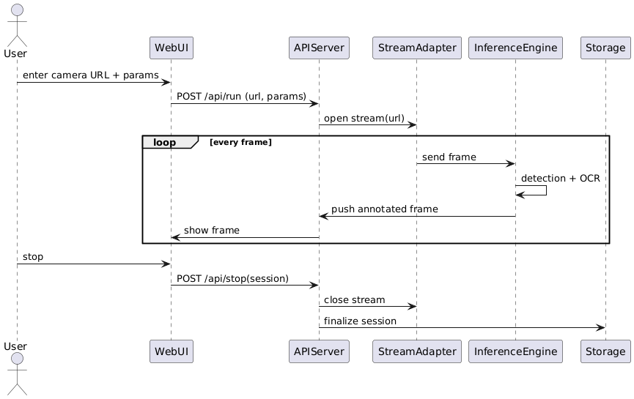

Project Structure and Implementation
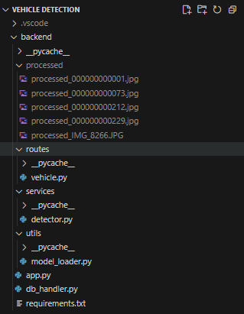
vehicle.py
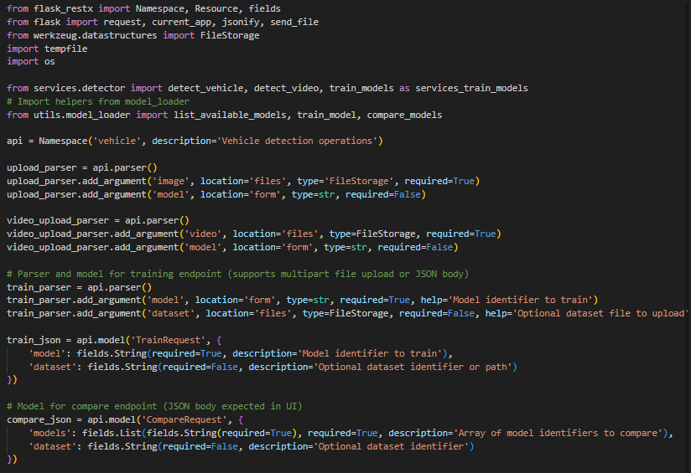

app.py
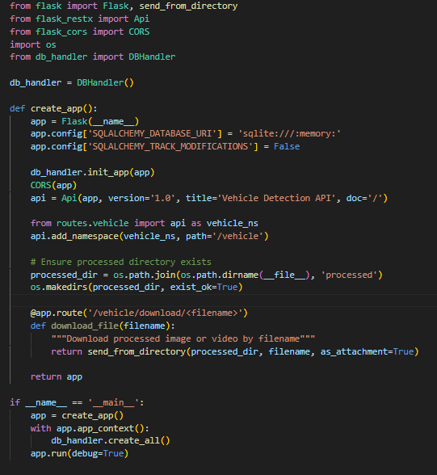

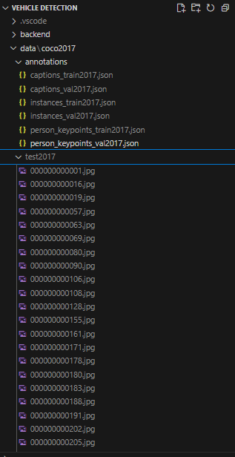

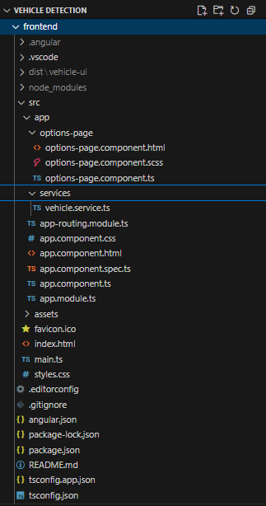

options-page.component.html
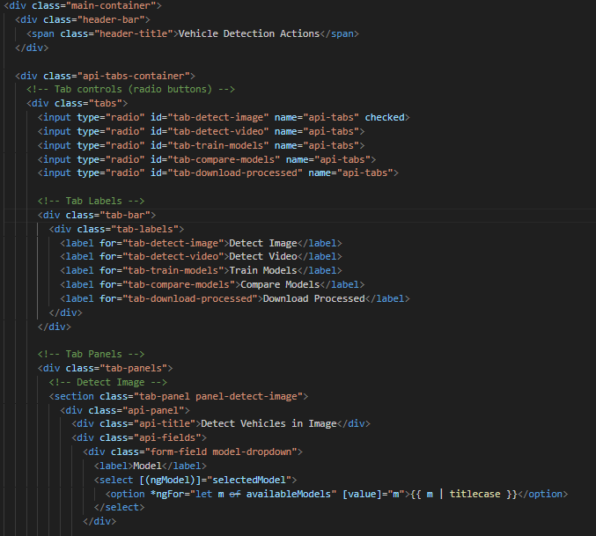
options-page.component.ts
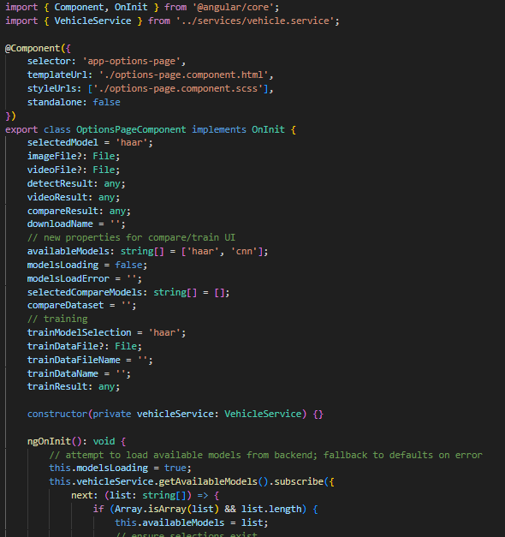
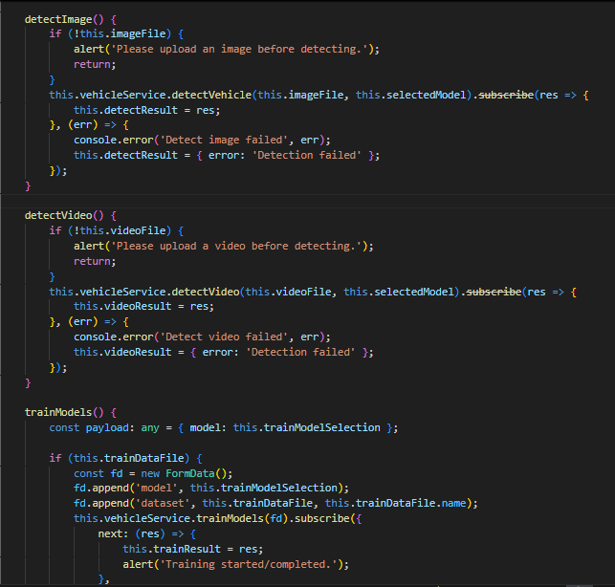

vehicle.service.ts
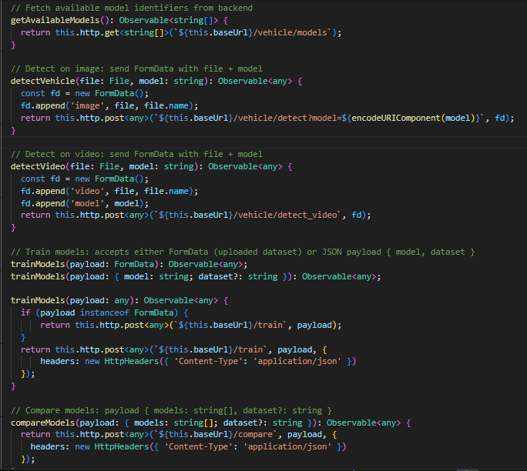

User Interface Design

Detect Image Screen
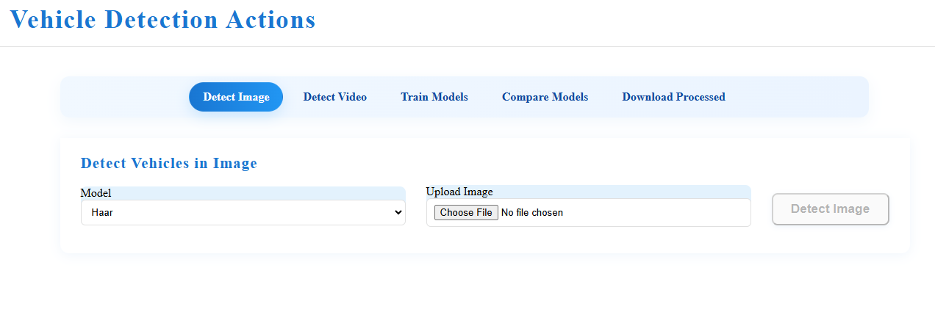

Detect Video Screen
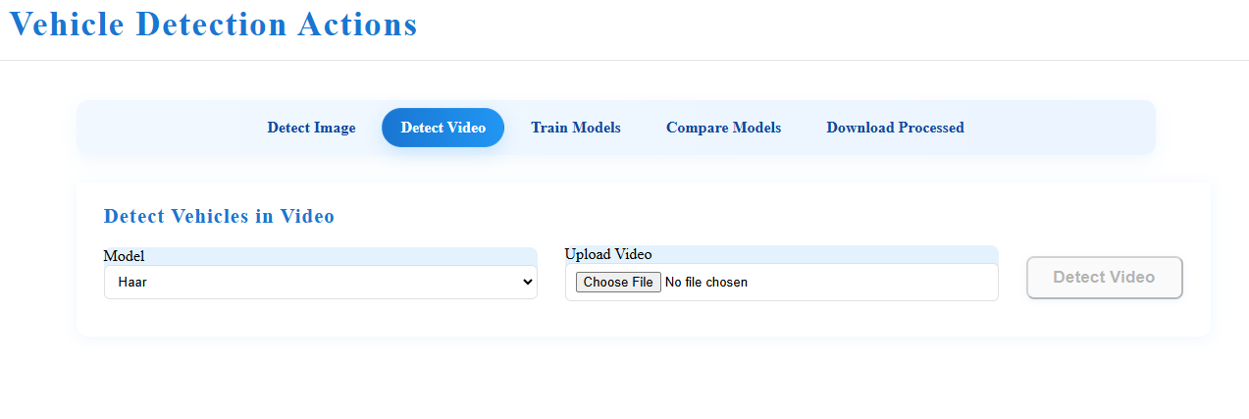

Train Model Screen
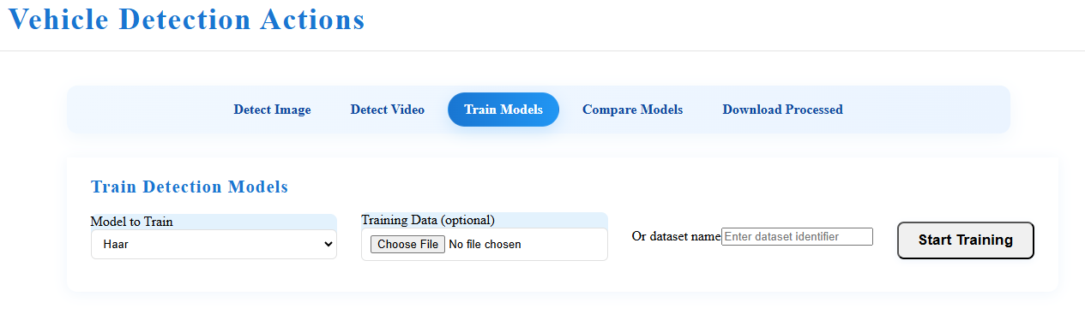

Compare Model Screen
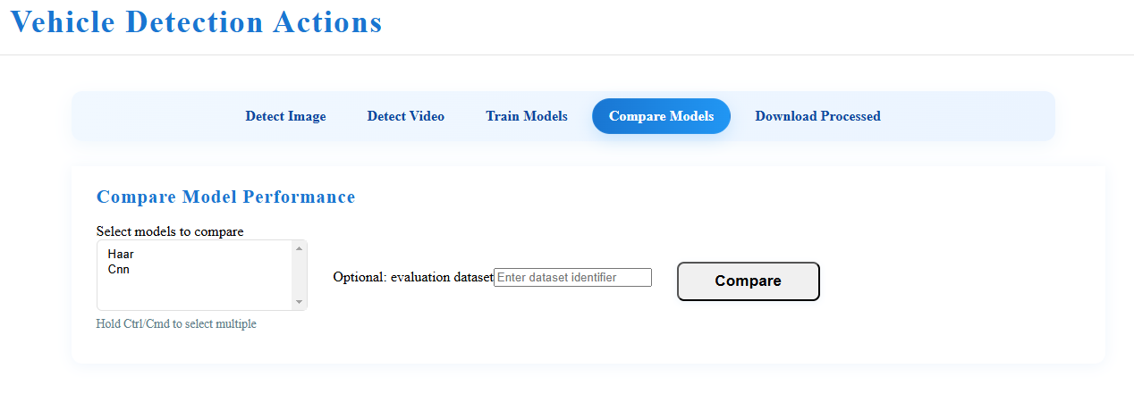

Download Processed Result Screen
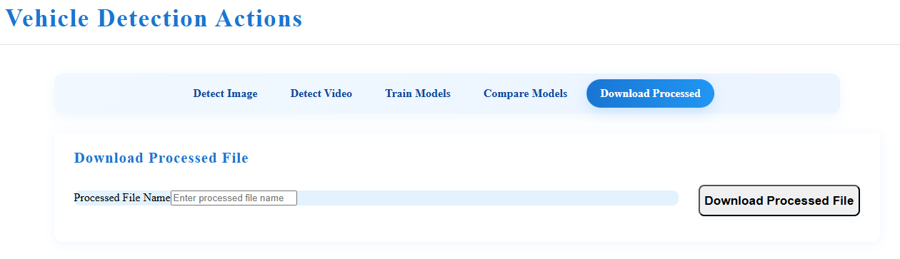

Testing and Evaluation
Test Case Number: TC1 - API Health & Swagger Availability
Description
Verify that the Flask backend is running and Swagger documentation loads successfully on port 5000.
Pre-Test Setup
- Python virtual environment active
- pip install -r backend/requirements.txt completed
- Backend server started with python backend/app.py

Use Case / Flow
Use Case: UC-0 (System Setup)
Flow: Main Flow
Steps
Step | User Action | Expected Results | Comments
1 | Open browser and navigate to http://localhost:5000/ | Swagger UI loads showing /vehicle/detect_image, /vehicle/detect_video, /vehicle/download/<filename> | Confirms REST API is up
2 | Expand /vehicle/detect_video | Shows parameter details (file, model) and response schema | Validates API documentation

Post-conditions
- Backend confirmed operational and ready for detection tests.

Test Case Number: TC2 - Image Detection with Haar Model
Description
Test that the system processes a static image using Haar Cascade and returns annotated output.
Pre-Test Setup
- Valid .jpg image containing at least one vehicle
- Backend running on port 5000
Use Case / Flow
Use Case: UC-1 (Image Detection)
Flow: Main Flow
Steps
Step | User Action | Expected Results | Comments
1 | Send POST /vehicle/detect_image with multipart form-data { file=car.jpg, model=haar } | HTTP 200 response with JSON { job_id, output_name } | Confirms detection job created
2 | Send GET /vehicle/download/<output_name> | Downloaded file contains bounding boxes around vehicles | Output saved under backend/processed/
3 | Check backend/processed/ folder | File exists with correct timestamped name | Confirms persistence

Post-conditions
- Annotated image stored successfully.
- Job metadata recorded in in-memory DB.

Test Case Number: TC3 - Video Detection with Haar Model
Description
Verify that a video is processed frame by frame with Haar Cascade and downloadable as
annotated video.
Pre-Test Setup
- Sample .mp4 video with vehicles (30–60s)
- Backend running
Use Case / Flow
Use Case: UC-2 (Video Detection)
Flow: Main Flow
Steps
Step | User Action | Expected Results | Comments
1 | Send POST /vehicle/detect_video with { file=traffic.mp4, model=haar } | HTTP 200 JSON { job_id, output_name } | Backend accepted video
2 | Monitor backend console | Logs show frame-by-frame detection messages | Confirms processing loop active
3 | Send GET /vehicle/download/<output_name> | Annotated .mp4 downloaded | File written in backend/processed/
4 | Play the downloaded video | Bounding boxes visible on vehicles frame by frame | Confirms correctness

Post-conditions
- Processed video available in processed/.
- Processing time logged in the backend.

Test Case Number: TC4 - Image Detection with CNN Model
Description
Test that CNN model can be selected for image detection and compare its result with Haar
output.
Pre-Test Setup
Same image as TC2 (car.jpg)
Backend running
Use Case / Flow
Use Case: UC-1 (Image Detection)
Flow: Alternate Flow
Steps
Step | User Action | Expected Results | Comments
1 | Send POST /vehicle/detect_image with { file=car.jpg, model=cnn } | JSON { job_id, output_name } | Confirms CNN model triggered
2 | Download file via /vehicle/download/<output_name> | Image annotated with CNN-based bounding boxes | File saved in processed/
3 | Compare Haar vs CNN outputs | CNN shows more robust detections (fewer false positives) | Manual validation

Post-conditions
- Both Haar and CNN outputs are available for comparison.

Test Case Number: TC5 - Frontend Upload & Download Flow
Description
Ensure that Angular frontend integrates correctly with backend API for upload and download.
Pre-Test Setup
- Run npm install && ng serve in frontend/
- Access frontend at http://localhost:4200/
Use Case / Flow
Use Case: UC-UI (Frontend Interaction)
Flow: Main Flow
Steps
Step | User Action | Expected Results | Comments
1 | Open UI in browser and click Upload Video | File chooser appears | Confirms UI functional
2 | Select traffic.mp4, choose Haar model, click Run | API call made; success notification shown | UI ↔ API interaction
3 | Wait for completion and click Download | Processed video downloaded | File retrieved via /vehicle/download/
4 | Play the downloaded file | Bounding boxes present | Confirms frontend workflow works

Post-conditions
- User can complete full flow without using Swagger.

Test Case Number: TC6 - Unsupported File Format Handling
Description
Test that unsupported formats are rejected with clear error messages.
Pre-Test Setup
- Prepare invalid file format (e.g., sample.mkv).
Use Case / Flow
Use Case: UC-2 (Video Detection)
Flow: Exception Flow
Steps
Step | User Action | Expected Results | Comments
1 | Send POST /vehicle/detect_video with { file=sample.mkv, model=haar } | HTTP 400 error with JSON { error: "Unsupported format. Allowed: .jpg, .png, .mp4, .avi" } | Error handled gracefully
2 | Check backend/processed/ folder | No output file created | Prevents junk output

Post-conditions
- No processed file saved.
- API returns a meaningful error message.

Ethical and Societal Impact
- Potential for surveillance misuse — project intended only as a demo
- Ensures privacy (blur option, retention policy)
- Educational contribution to computer vision research

Results and Discussion
- Haar Cascade: fast but less accurate; CNN is more robust
- Successful integration of Angular + Flask + OpenCV
- Annotated outputs downloadable; evaluation metrics available
- Limitations: no GPU scaling, not production-ready

Conclusion and Future Work
- Achieved a working prototype of vehicle and trying to achieve license plate detection.
- Demonstrated full-stack integration (UI + backend + ML pipeline).
- Future enhancements: YOLOv5 integration, GPU deployment, role-based access, multi-user scaling

Appendices
Appendix A: Test cases (detailed TC1–TC6)
Appendix B: UML diagrams (Use Case, Class, Sequence)
Appendix C: Screenshots of UI and outputs

